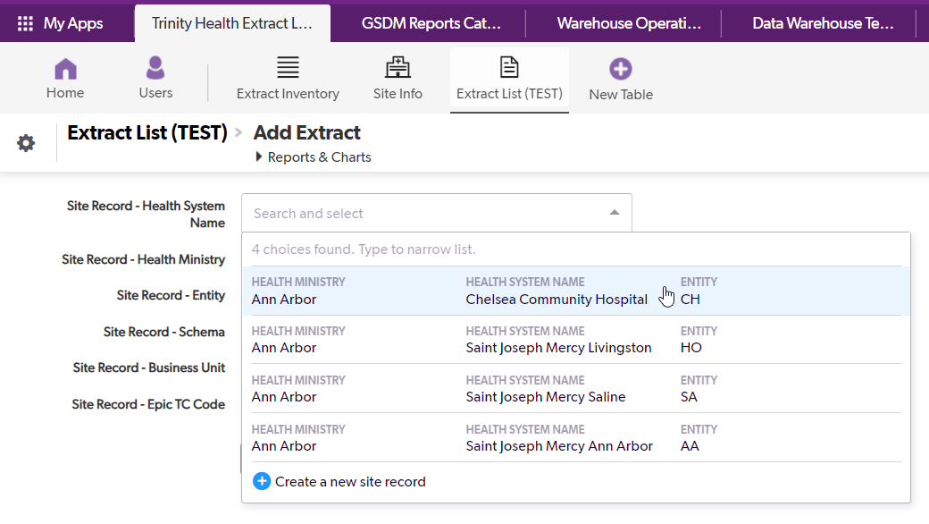

I want to change the fields that appear in the selection box but do not know where that is set up.

When I make a selection from the list, the Health System Name field populates with the Health Ministry name instead – until I save the record.

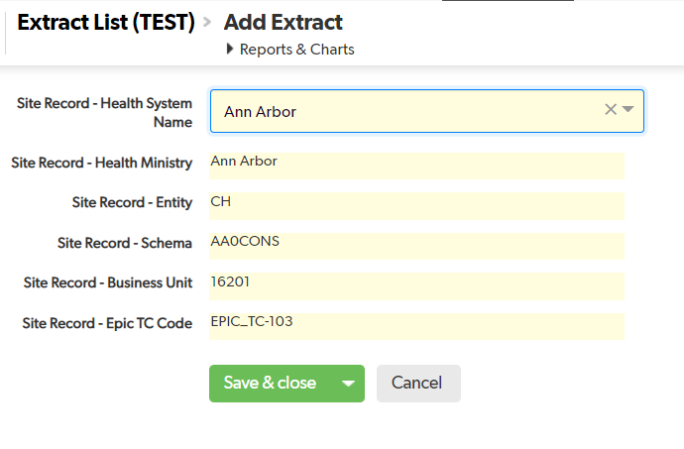

This is how I want the record to look when I select the Health System Name and before I save.

